Car-Insurance Company Database Systems

An Assignment submitted in partial fulfillment of the requirements for the degree of
Bachelor of Science
in
Computer Science

CS 3306: Databases 2

Term 4 - 2025
University of The People

Instructor: Dr. Afrah Nazir

April 16, 2026

Car-Insurance Company Database Systems
1. (a) Design an entity-relationship data model for a car-insurance company whose customers own one or more cars each. There are zero to any number of accidents recorded for each car.

Phase 1: E-R Model Design

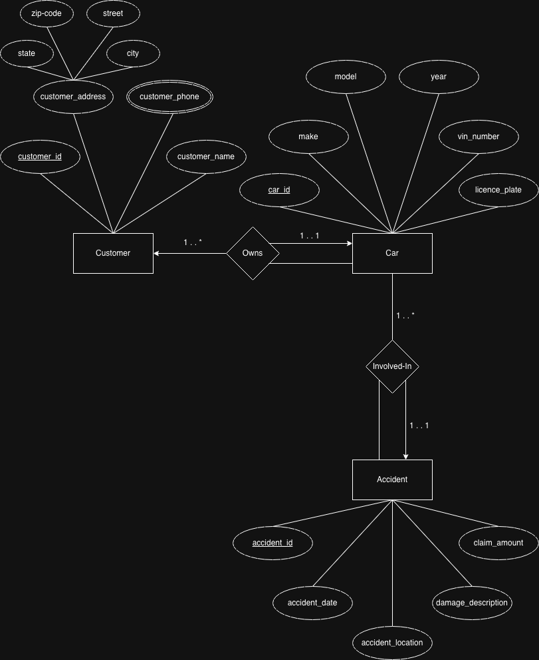
The E-R model for the car-insurance company is designed to capture the core entities and their interactions. We identify three primary strong entity sets: Customer, Car, and Accident [cite: 1, 2].
- Customer: Represented as a strong entity with customer_id as the primary key. It includes attributes for name, phone, and address [cite: 1, 4].
- Car: A strong entity uniquely identified by car_id. It tracks mechanical details such as make, model, year, and VIN [cite: 2, 5].
- Accident: An independent entity set recording incident details like date, location, and claim amount [cite: 2, 5].
1. (b) Provide an example of each of the following three concepts within your model: Primary key, Composite attribute, and Multi-valued attribute.

Phase 2: Attribute concepts
In designing the schema, we implement specific attribute types to handle data complexity:
- Primary key: The customer_id is the primary key for the Customer entity, ensuring each record is uniquely identifiable [cite: 1, 4].
- Composite attribute: The customer_address is a composite attribute, meaning it is divided into sub-parts such as street, city, state, and zip-code for better granularity.
- Multi-valued attribute: The customer_phone is a multi-valued attribute, as customers may possess multiple contact numbers. In a standard E-R diagram, this is indicated by a double-ringed ellipse.
2. (a) Develop a set of tables with several entries from the model. (b) Provide an example of a left join, a right join, and a full outer-join.

Phase 3: Relational Operations and Outer Joins
Outer join operations are essential for maintaining data integrity when joining tables where some records lack a corresponding match in the join partner [cite: 3].
Table: Customer (r)
customer_id | customer_name | customer_city
C-101 | Coyote | Hollywood
C-102 | Rabbit | Carrotville
C-103 | Smith | Death Valley

Table: Car (s)
car_id | make | customer_id
CAR-01 | ACME | C-101
CAR-02 | Burrow | C-102
CAR-03 | Tesla | C-104

Left Outer Join
A left outer join preserves all tuples from the left relation (Customer). If a customer (like Smith) has no matching car, the right-side attributes are padded with null [cite: 3].
customer_id | customer_name | car_id | make
C-101 | Coyote | CAR-01 | ACME
C-102 | Rabbit | CAR-02 | Burrow
C-103 | Smith | null | null

Right Outer Join
A right outer join preserves all tuples from the right relation (Car). If a car (like the Tesla) has an owner ID not found in the Customer table, the left-side attributes are padded with null [cite: 3].
customer_id | customer_name | car_id | make
C-101 | Coyote | CAR-01 | ACME
C-102 | Rabbit | CAR-02 | Burrow
null | null | CAR-03 | Tesla

Full Outer Join
A full outer join combines the logic of both, ensuring no information from either side is lost [cite: 3].
customer_id | customer_name | car_id | make
C-101 | Coyote | CAR-01 | ACME
C-102 | Rabbit | CAR-02 | Burrow
C-103 | Smith | null | null
null | null | CAR-03 | Tesla

3. (a) Give examples for mapping cardinalities: 1:1, N:1, 1:N, and M:N. (b) Explain why the cardinality is appropriate for each.

Phase 4: Mapping Cardinalities
Mapping cardinalities define the number of entities to which another entity can be associated via a relationship set [cite: 3].
  - One-to-One (1:1): A Car and its VIN (Vehicle Identification Number). One car has exactly one VIN, and one VIN belongs to exactly one car. This is appropriate to ensure unique legal registration and part tracking.
  - Many-to-One (N:1): Accidents to a Car. Multiple accident records can be associated with a
single car, but each specific accident incident record involves exactly one primary car [cite: 3, 4]. This is appropriate for risk profiling.
  - One-to-Many (1:N): Customer to Cars. One customer can own many cars, but every car
must have exactly one primary owner [cite: 3, 5]. This reflects legal ownership requirements (Total Participation on the Car side) [cite: 3, 5, 6].
  - Many-to-Many (M:N): Drivers to Cars. Many drivers can be insured to drive many different cars in a household policy. This reflects real-world flexibility where vehicles are shared among family members.

